

CE Credit for Association Membership

The Issue

Continuing Education (CE) is an essential part of any financial services professional's training. The industry is forever growing and shifting as consumers' needs grow and evolve. Participation and membership with an industry association provide valuable education and insights to its member and accomplishes many of the same goals and traditional or web-based continuing education (CE) credits. Several states have enacted laws or regulations that permit financial advisors to receive a portion of their required continuing education (CE) credit for their active membership and participation in a professional agent trade association.

NAIFA Position

NAIFA strongly supports legislation that would permit insurance producers to receive CE credit for their membership in a professional insurance association. Professional insurance associations, like NAIFA, promote high standards of ethical conduct among their members and provide educational programs and professional development opportunities to association members. We believe that state proposals to allow advisors to receive some CE credit for association membership could encourage financial advisors to join professional insurance associations, ultimately benefiting consumers by providing access to better-qualified advisors.

The NAIFA Continuing Education Credit for Membership in a Professional Insurance Association Model Act would allow financial advisors to receive up to four hours of CE credit per reporting period for a professional insurance association membership. Under the NAIFA model, members must demonstrate active participation in the association to qualify for such CE credit. The NAIFA model gives authority to state insurance commissioners to define the term "active participation," specify the associations where membership would be eligible for CE credit, and require any other criteria the commissioners may deem necessary. The NAIFA model legislation is based on laws already enacted in some states.
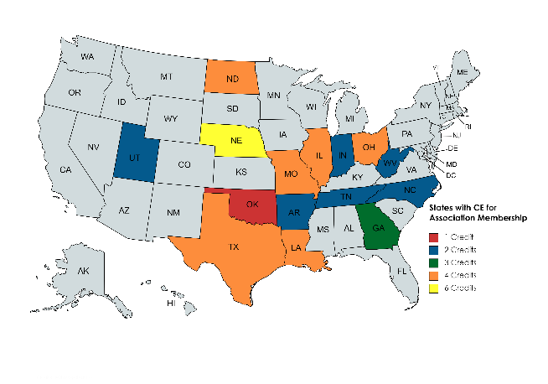
As of May 2023, 15 states allow continuing education (CE) credit for membership of a professional insurance association.

